A guide to support parents using Times tables RockStars at home.
- When your child logs on, they need to select single player-
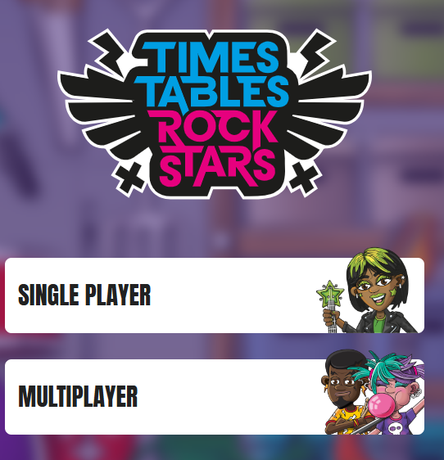
- Your child will have the option to select a mode to play in (unless their teacher has set a particular session). Garage mode allows your child to access their own individual heat map.
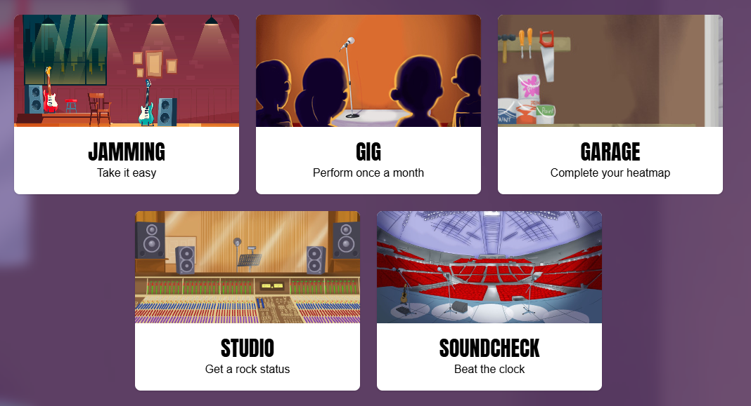
- Here you can see which times tables have been set by your teacher.
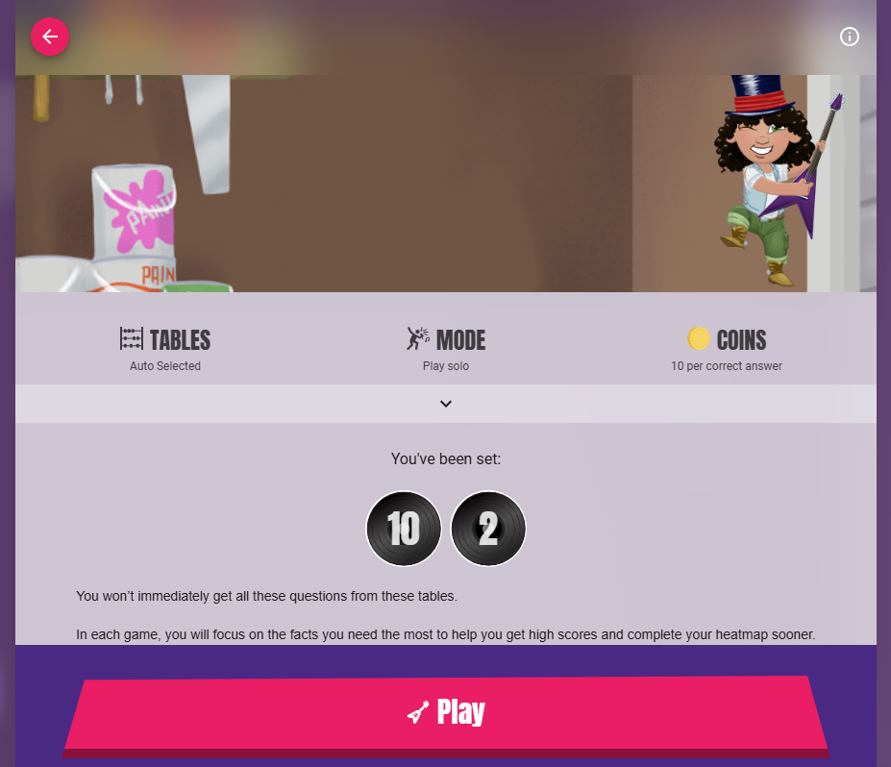
- Whilst on this page, you can scroll down and see your child’s heatmap. In each game, your child will focus on the facts they need the most to help them get high scores and complete their heatmap sooner. When your child presses ‘play’ they can start jamming!
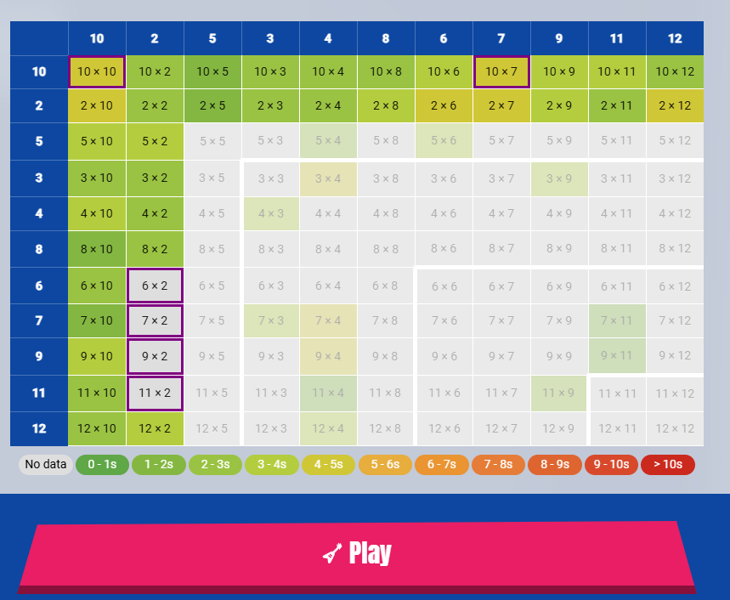
- At the end of each session, you will be able to review your child’s results. Click on ‘see more’
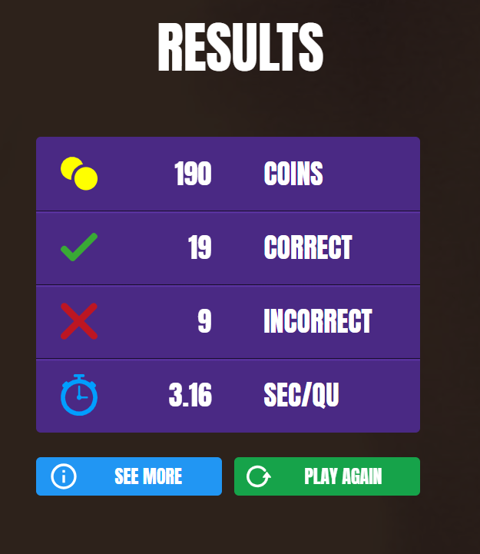
- Here you can review your child’s average speed per question and look at what answers your child gave.


