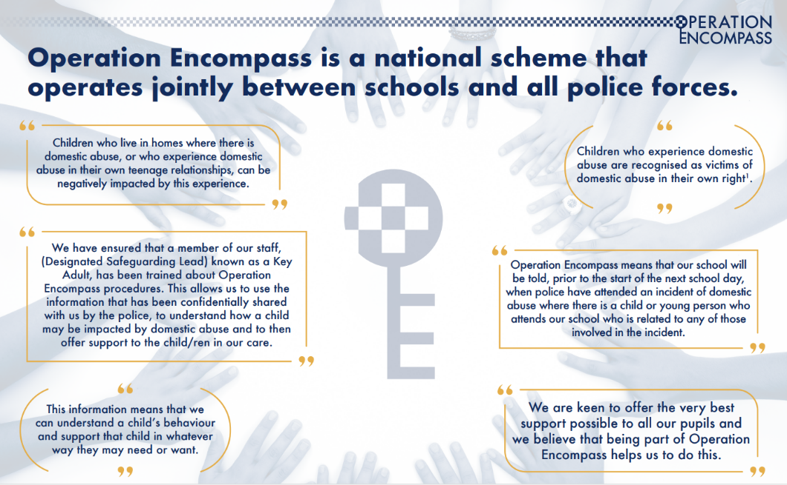
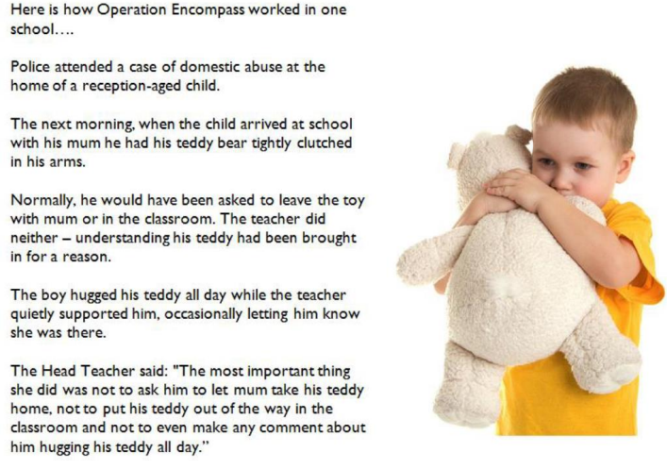

Operation Encompass is an initiative to share important information between the police and schools when then there has been a domestic incident.
The purpose of the initiative is to make sure that the school has the correct information in order to support children sensitively when they come into school.
Police share information with Social Care and information is shared with school via email or phone call to let them know the name of the child/ren involved and the date of the incident. The Operation Encompass key adult will record all details and ensure that the child/ren is supported appropriately. The information will be treated confidentially as with all safeguarding information. For more information please contact school.

