Books to help with feelings and emotions

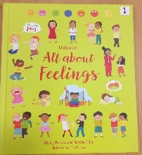
All about feelings by Usborne
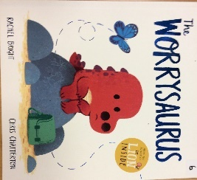

Worrysaurus by Rachel Bright and Chris Chatterton
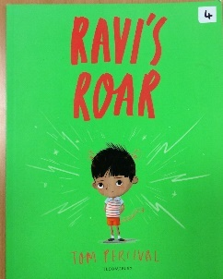
Ravis Roar by Tom Percival

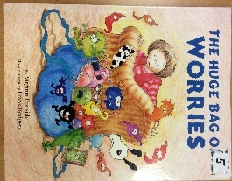

Huge bag of Worries by Virgina Ironside
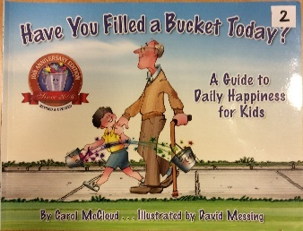
Have you filled your Bucket today by Carol McCloud
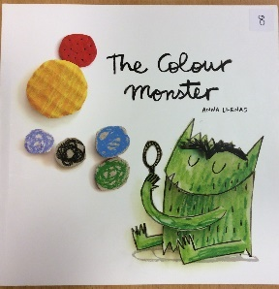

The Colour Monster by Anna Llenas
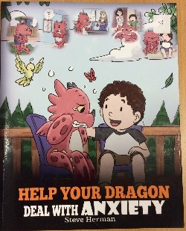

Help your Dragon deal with Anxiety by Steve Herman

Books to help with loss and bereavement

When Butterflies paint the sky by Hayley Sturridge-Packer
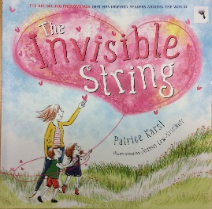

The invisible String by Patrice Karst
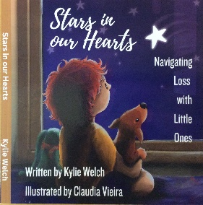

Stars in our hearts by Kylie Welch
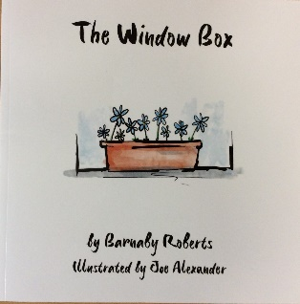

The Window Box by Barnaby Roberts.

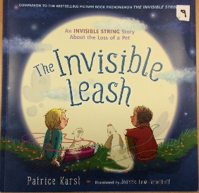

The Invisible Leash by Patrice Karst
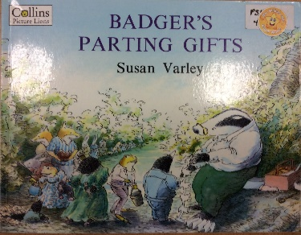

Badgers Parting Gifts by Susan Varley

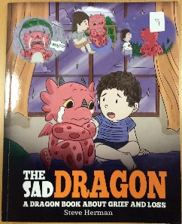

The Sad Dragon by Steve Herman

Books to help with trauma and relationships
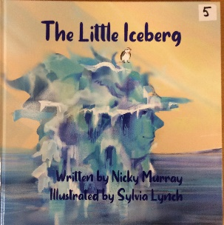
The Little Iceberg by Nicky Murray

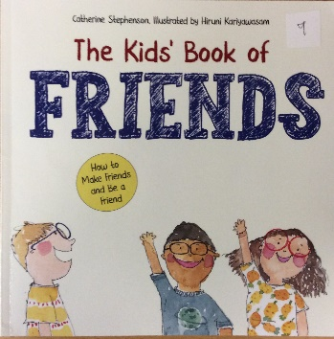

The Kids’ Book of Friends by Catherine Stephenson

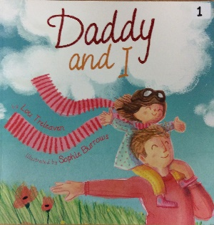

Daddy and I by Lou Treleaven

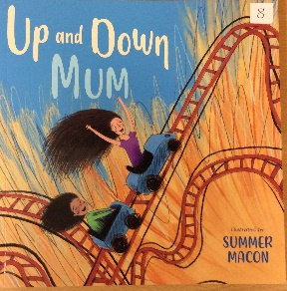

Up and Down Mum by Welcome

Books to help with feeling different
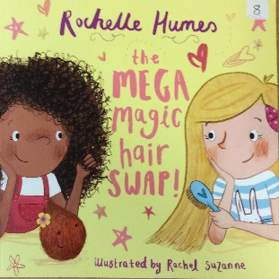

The Mega magic Hair Swap by Rochelle Humes

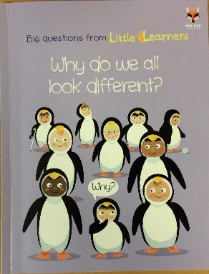

Why do we all look different? by Little Learners

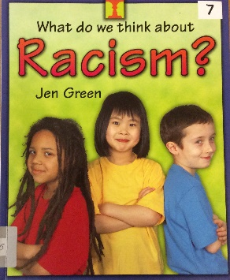
What do we think about Racism by Jen Green

Books to help with Transition
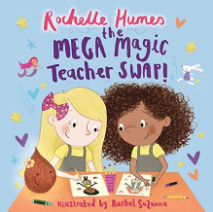
The Mega Magic Teacher Swap by Rochelle Humes

Books to help with sharing and accountability

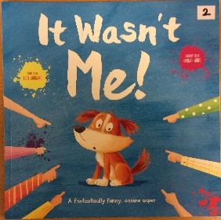
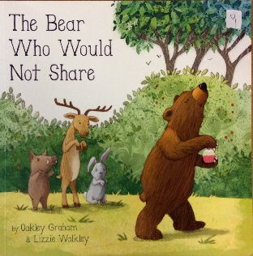
It Wasn’t Me by Lucy Barnard
The Bear Who Wouldn’t Share by Oakley Graham

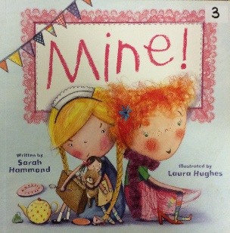
Mine by Sarah Hammond

Books to help Tricky Eaters
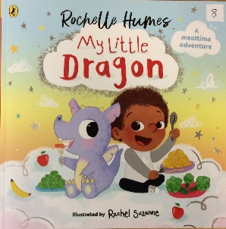
My Little Dragon by Rochelle Humes

At www.MyDragonBooks.com you will find a range of books to help parents answer common difficulties.

Websites
Childbereavementuk.org – parents can contact these direct for help.
elsa-support.co.uk – great advice and some printable resources.

