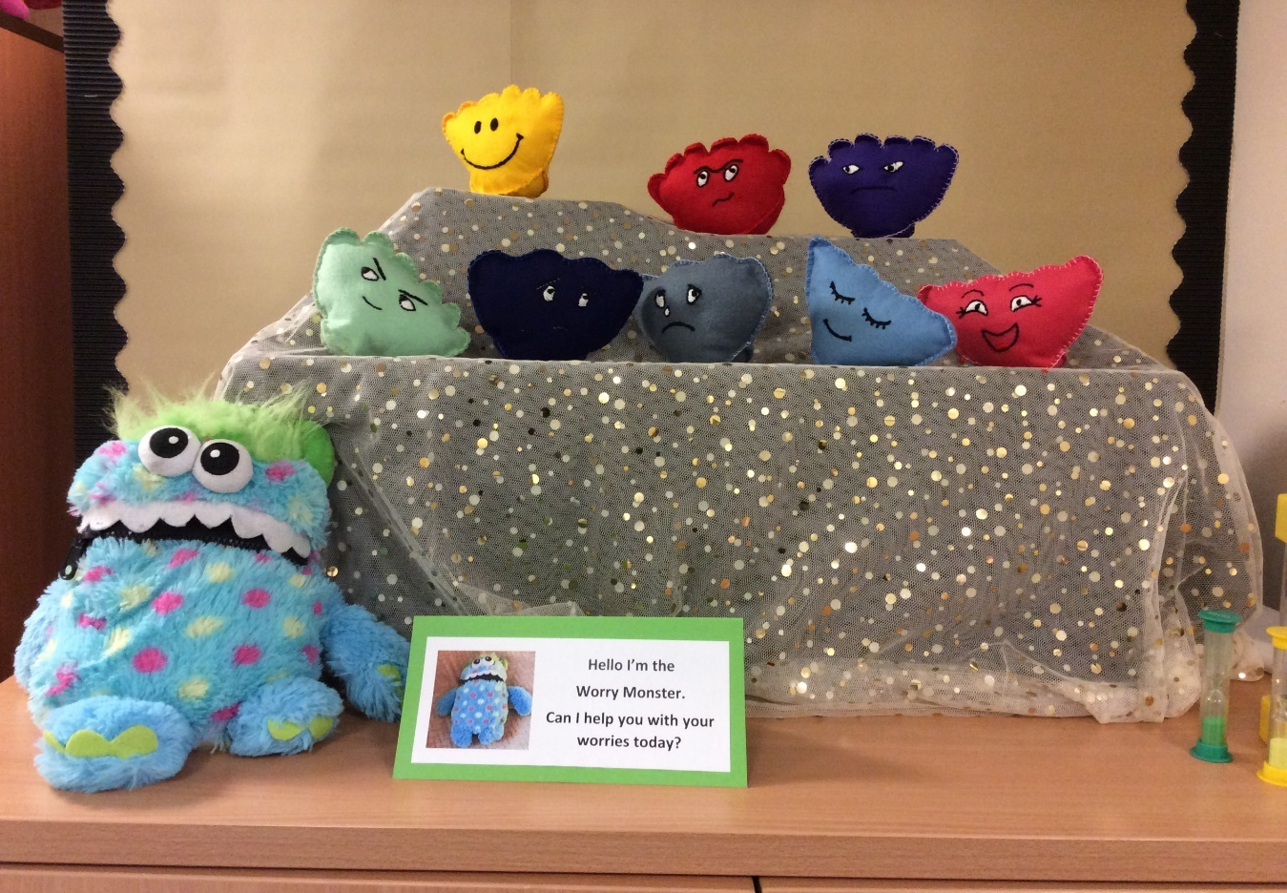
Learning together isn’t just about knowledge—it’s about feelings too. Joy, curiosity, and empathy create a classroom where every child feels valued and connected.
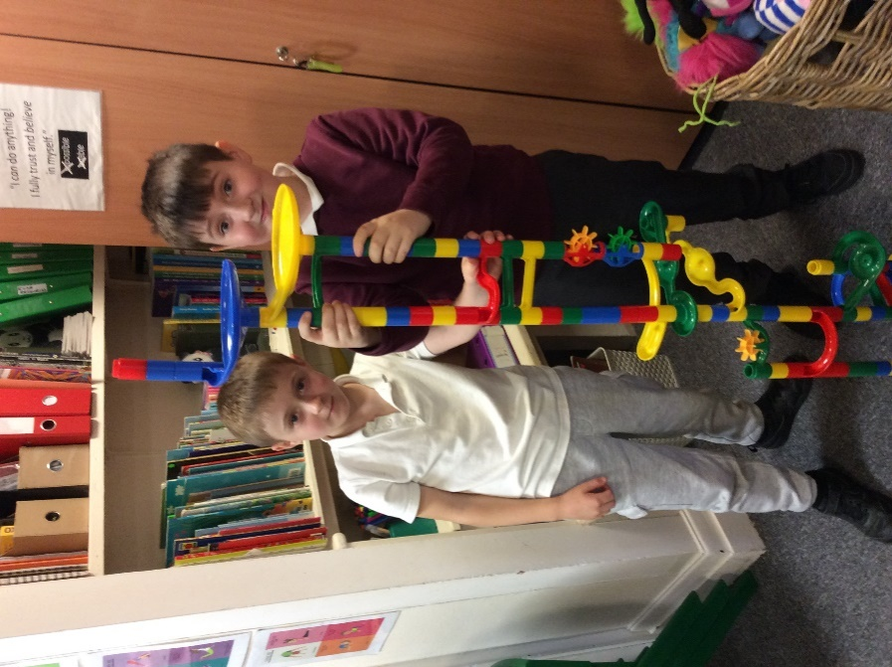
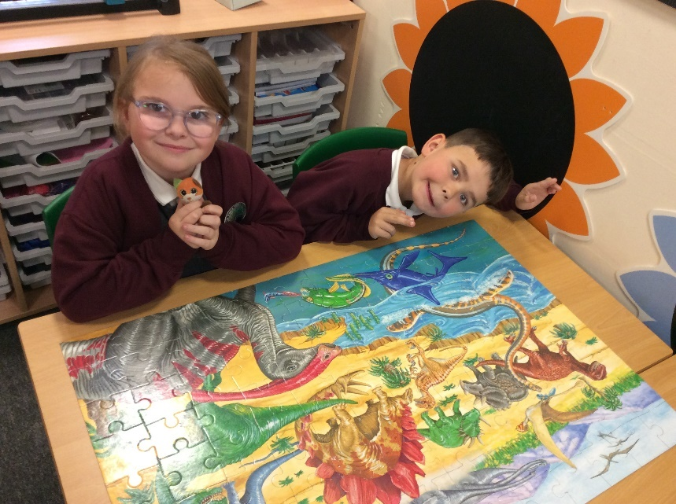
Jigsaw puzzles help children develop problem-solving skills, patience, and spatial awareness while fostering teamwork and communication.
Teamwork makes the dream work—even at home! When brothers and sisters build together, it’s like magic: more giggles, more ideas, and double the fun!
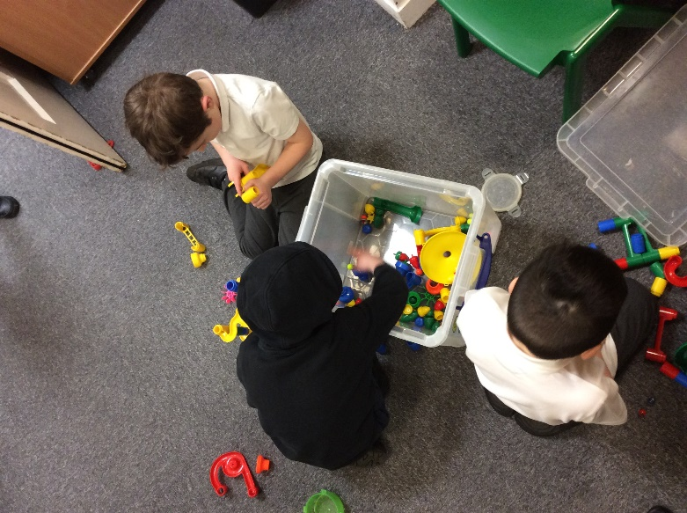
Collaboration sparks creativity! When children play together, they learn to share ideas, solve problems as a team, and build social skills that last a lifetime
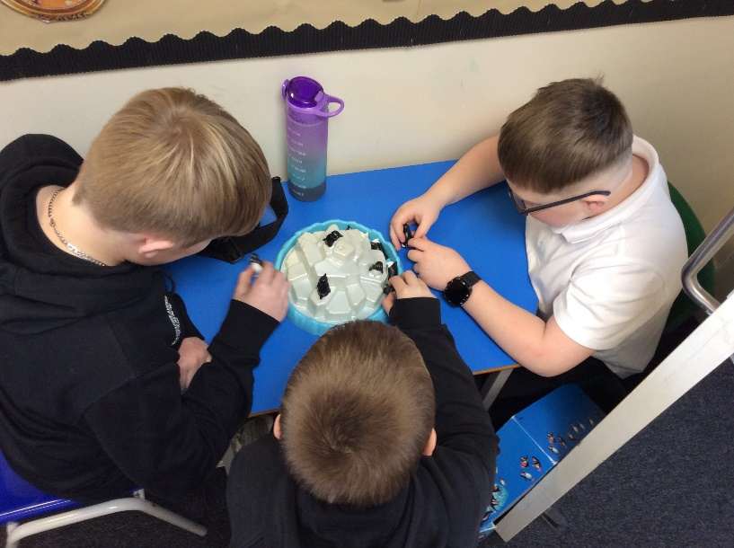
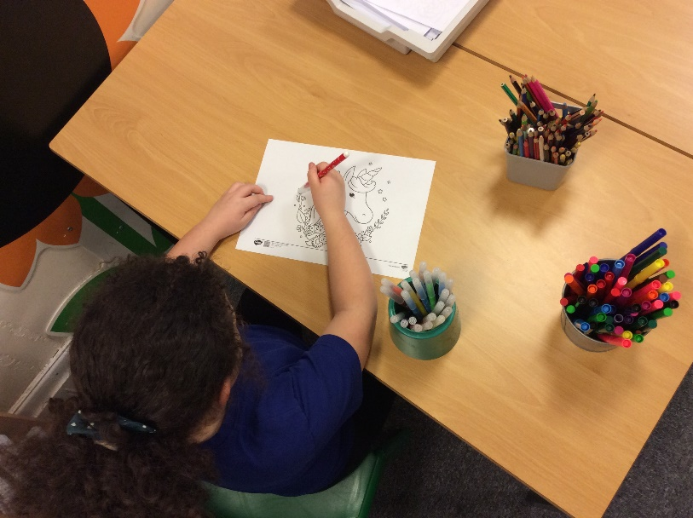
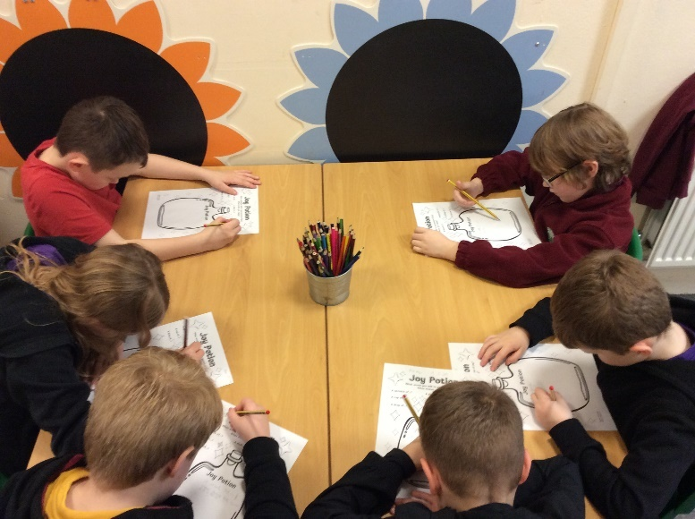
Colouring isn’t just art—it’s mindfulness in action. When children focus on filling shapes with colour, they practice concentration, fine motor skills, and self-expression. These calm moments nurture creativity and emotional regulation, helping little minds grow resilient and confident.
Friendship blooms in the little moments—sharing snacks, swapping stories, and laughing together. Breaktime isn’t just a pause; it’s a chance to build trust, kindness, and social skills.
Joy is more than a feeling—it’s a skill we learn together. When children discover joy in play, puzzles, and teamwork, they build resilience, empathy, and a love for learning.

