
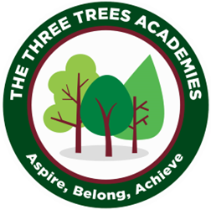
This is an overview of the spellings which will be taught and tested during Summer Term 1 in Year 3.
Every Friday your child will be tested on 10 words from a spelling pattern/ rule taught each week in class. Please help your child practise these at home.
 | Week 1 to be tested on 17.4.26 /ae/ | Week 2  to be tested on 24.4.26 /ee/ | Week 3  to be tested on  1.5.26 /ea/ | Week 4 to be tested on 8.5.26 /oe/ | Week 5  to be tested on 15.5.26 /o/ | Week 6  to be tested on 22.5.26 /er/
 | bake | bleed | bleak | boat | dog | germ
 | came | meet | steam | coat | frog | fern
 | break | creak | clean | go | nod | bird
 | great | stream | gleam | so | hot | girl
 | game | tummy | team | crow | from | shirt
 | take | funny | sneak | snow | both | word
 | train | she | speak | phone | post | work
 | drain | he | great | stroke | host | hurt
 | play | we | break | toe | yo-yo | turn
 | way | me | steak | Joe | most | curl
Phonics Group

