
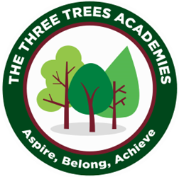
This is an overview of the spellings which will be taught and tested during Summer Term 2 in Year 3.
Every Friday your child will be tested on 10 words from a spelling pattern/ rule taught each week in class. Please help your child practise these at home. There will be no test in Week 7.
 | Week 1 to be tested on 5.6.26 | Week 2  to be tested on 12.6.26 | Week 3  to be tested on  19.6.26 | Week 4 to be tested on 25.6.26 | Week 5  to be tested on 3.7.26 | Week 6  to be tested on 10.7.26
 | high | forty | saw | air | bear | dolphin
 | light | north | yawn | pair | wear | phonics
 | right | horse | author | chair | dare | when
 | tight | score | autograph | fairy | share | which
 | fright | wore | astronaut | hairy | mare | while
 | night | morning | draw | ear | pear | alphabet
 | bright | torn | crawl | hear | bare | elephant
 | sight | more | August | year | care | where
 | mighty | before | lawn | near | scare | wheel
 | midnight | shore | drawn | clear | hare | white
Group B

