
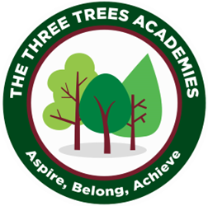
This is an overview of the spellings which will be taught and tested during Summer Term 2 in Year 3.
Every Friday your child will be tested on 10 words from a spelling pattern/ rule taught each week in class. Please help your child practise these at home.
 | Week 1 to be tested on 5.6.26 /oe/ | Week 2  to be tested on 12.6.26 /o/ | Week 3  to be tested on  19.6.26 /er/ | Week 4 to be tested on 26.6.26 /e/ | Week 5  to be tested on 3.7.26 /ow/ | Week 6  to be tested on 10.7.26 /oo/
 | boat | dog | germ | chest | bow | moon
 | coat | frog | fern | rent | gown | soon
 | go | nod | bird | sent | clown | bloom
 | so | hot | girl | Ben | crowd | proof
 | crow | from | shirt | peck | brow | rude
 | snow | both | word | then | wow | dude
 | phone | post | work | tent | brown | june
 | stroke | host | hurt | said | mouse | brute
 | toe | yo-yo | turn | friend | couch | blue
 | Joe | most | curl | dreamt | count | true
Phonics Group

