Wheels in Motion : Summer 2 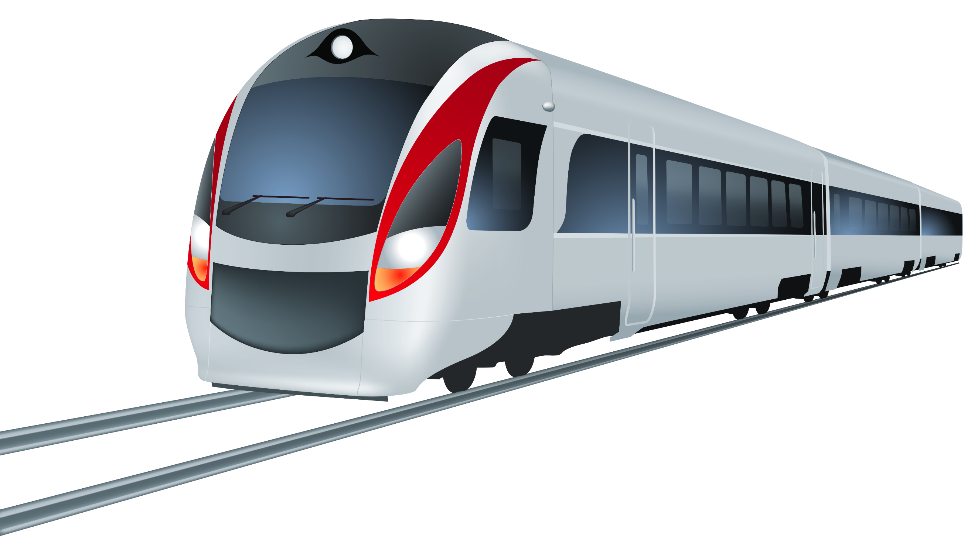
Expressive Arts and Design with an Understanding the World link
We will be learning about what waterproof means and we will be testing different materials to see whether they are waterproof.
Floating and Sinking we will test and make predictions for which materials float or sink.
We will then design and build boats using different materials and test them.

Personal Social and Emotional Development
We will learning about road safety- how to keep safe near roads and when crossing the roads.
We will be learning about listening to our feelings- to be able to name adults who they can trust to ask them for help and to keep them safe.
We will be developing our understanding of how to keep safe online and what to do and who to talk to if they feel unsafe.
We will be looking at how to look after our bodies and keeping healthy.
In Early Years Foundation Stage this half term, we will be learning about different types of transport. We will be looking at our journeys to school and the different ways that we travel. We will be completing a traffic survey in our local area to see which is the most popular form of transport and how we can travel using different types of transport. This term we will beginning our transitions to Year One

What you can do to help at home:
Please listen to your child read every day and sign and date the record. Please continue to use Tapestry to share your child’s achievements at home, we love to see what they are getting up to at home!
Practice correct letter formation and number formation at home- this could be using water and paintbrushes or chalk outside, paints etc . Please continue to practice reading, writing and spelling high frequency words with your child.
Understanding the World
We will be looking at different journeys i.e. how do we get to school, what is a journey and exploring an aerial view of where we live and the local area.
We will be exploring what kinds of transport we might find on the road- through a traffic survey and exploring a car.
We will be exploring space travel by learning about rockets and rocket launches and famous astronauts (Mae Jaimeson, Tim Peake)
We will be looking at the different parts of a plane and how a plane moves– Transport around the World (Tuk Tuk, Gondola, Dog Sled)
Mathematics
In maths this half term we will continue working on our skills of:
-counting beyond 20
-finding one more and one less
-knowing number bonds to 5 and 10
- sharing and grouping numbers.
We also will be working on visualising and creating patterns and models using shape and exploring and creating maps.

Literacy
We will continue to explore fiction & Non-fiction texts but about transport.

We will create fact books about transport and notice the difference between writing stories and writing information.

We will be able to read sentences back that we have written.

To read and spell some tricky words.

To be able to form most lower case letters correctly.
Physical Development
We will continue to develop our fine motor skills using small tools such as cutlery, tweezers, pipettes, scissors.
In PE we will be working on ball skills- kicking, throwing, catching, passing and controlling large and small balls.
Communication and Language
We will continue to ask questions to understand why things happen e.g. who, what, when and how.
We will continue to use intonation and rhythm when joining in with stories and rhymes.
We will respond to questions using full sentences e.g. I think… because…
We will use newly acquired vocabulary to name and describe.

