
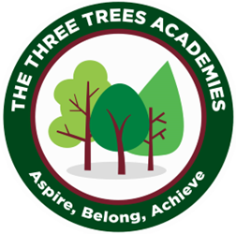
This is an overview of the spellings which will be taught and tested during Autumn Term 1 in Year 3.
Every Friday your child will be tested on 10 words from a spelling pattern/ rule taught each week in class. Please help your child practise these at home. There is not a test in Week 1.
 | Week 2 to be tested on 18.9.26 | Week 3  to be tested on 25.9.26 | Week 4  to be tested on  2.10.26 | Week 5 to be tested on 9.10.26 | Week 6  to be tested on 16.10.26 | Week 7  to be tested on 23.10.26
 | mouth | touch | gym | adventure | sure | actual
 | ouch | double | myth | picture | unsure | bicycle
 | spout | country | Egypt | nature | measure | answer
 | sprout | trouble | pyramid | creature | treasure | circle
 | hound | young | mystery | capture | future | earth
 | around | couple | symbol | sculpture | furniture | enough
 | sound | enough | synonym | mixture | closure | fruit
 | trout | cousin | lyrics | fracture | enclosure | island
 | found | encourage | system | natural | pleasure | often
 | proud | flourish | gymnastics | unnatural | pressure | popular
Group A

