
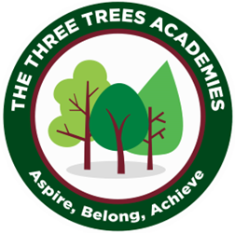
This is an overview of the spellings which will be taught and tested during Autumn Term 2 in Year 3.
Every Friday your child will be tested on 10 words from a spelling pattern/ rule taught each week in class. Please help your child practise these at home. There is not a test in Week 7.
 | Week 1 to be tested on 6.11.26 | Week 2  to be tested on 13.11.26 | Week 3  to be tested on  20.11.26 | Week 4 to be tested on 27.11.25 | Week 5  to be tested on 4.12.26 | Week 6  to be tested on 11.12.26
 | pocket | rain | day | made | even | five
 | football | wait | play | came | delete | ride
 | balloon | train | say | same | these | like
 | playground | paid | way | rake | Chinese | time
 | carrot | afraid | stay | take | these | side
 | farmyard | oil | clay | safe | complete | slide
 | thunder | join | toy | plate | evening | spike
 | bedroom | coin | joy | awake | athlete | trike
 | sunset | point | enjoy | mistake | eve | fire
 | starfish | soil | cowboy | snowflake | extreme | mine
Group B

